CHEERLEADER NAME

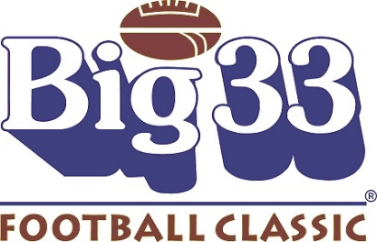
Sponsor Letter

Dear Sponsor,

It is with great pride to let you know that I have been selected to participate in the 65th Big 33 High School Football Classic Cheerleading Squad, which is also known as the “High School Super Bowl”. It is an elite group of players and cheerleaders who were chosen because they will make a major contribution to the success of Big 33 on May 30, 2022. Additionally, each cheerleader is to be congratulated for being a positive role model representing their high school cheering team with their conduct on and off the field.
Each Big 33 participant is required to secure sponsors for a program ad which will appear in the 2022 Big 33 Game Day Program. The program ad ranges from $150 to $450.00. It is a full color ad showcasing my accomplishments along with a list of my sponsors. With the contributions collected, I will receive the following items:

- Game Day Uniform – Cheerleaders keep their uniform
- Big 33 Attire: T-shirts to be worn for practices and various events
- (2) Tickets for 2022 Big 33 Football Classic
- Souvenir Game Day Program: every cheerleader receives one (with paid program ad)

I am honored to have been selected to participate in this historic game. There has never been a Super Bowl played without a Big 33 Alumnus. No other all-star game in the country has a Super Bowl Streak like the Big 33 Football Classic. Any amount is greatly appreciated. Thank you for your support.

Payment can be made online at www.big33.org or checks made payable to Big 33 and mailed to:
Big 33
4813 Jonestown Road, Suite 202
Harrisburg, PA 17109

Thank you kindly,

Cheerleader Name

